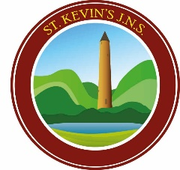
St Kevin’s Junior National School
10th September 2019

We had such a lovely two weeks meeting all our new students and catching up with all our returning students. It was lovely seeing how tall some have grown and hearing their stories of adventures and fun over the summer months.
We are delighted to see all our classes walking into class independently every morning and waiting in their line for ten to nine. Supervision is not available prior to 8:50am therefore it is important that all children are supervised by their parents/caregivers each morning and standing in their line.
On rainy mornings our school Principal or Deputy Principal may open the side/hall doors early (8:40) to avoid children getting wet however this depends on having an appropriate number of staff for supervision.
Apologies however due to space restrictions we cannot extend an invitation to Parents/Care Givers to wait in the hall.
Late/ Early Collection:
In the unlikely event of a late collection it is important you contact the office by phone or email to explain the reason for lateness & estimated time of arrival likewise, with early collections.
School Resources/ Arts & Craft Fees
Thank you to all our families that have paid their book list fees, a Reminder text/ note will be issued to families who have not contributed over the next few days. Please ensure all monies are placed in an envelope with your child’s names clearly written. Money can be given to the class teacher or the secretary. Unfortunately, online payments cannot be accepted at this time. Details in relation to the fees are clearly outlined on the booklists. We are mindful of the pressures placed on families at this time therefore we continue to accept part payments.

Healthy Lunch Policy
In St Kevin’s we promote a healthy lunch policy therefore we do not permit sweets, crisps, chocolate (including chocolate spread) or fizzy drinks. Please ensure you provide a healthy lunch for your child every day. Dublin City Corporation will provide sandwiches, milk & fruit to our students from Monday. Please remember we are a nut-free zone! Therefore, no chocolate spread or food products that contain any type of nut is allowed on the school premise. We appreciate your ongoing support in relation to this request.

.

Our school photographer, Simon Archer will be in tomorrow (Wednesday) to take class photos and individual photographs of our Junior Infant children. Please be advised you are under no obligation to purchase photographs. Sample images will be issues prior to payment & siblings may be included in the photograph on request. Check out http://www.simonarcher.ie/ for additional information in relation to Simons work and samples of his work.

Yard Activities
We like to ensure our children are experiencing fun in the yard with their friends and getting some exercise. Therefore, during our big break our 2nd class yard buddies will bring out some of our sports equipment for the children to play with. This equipment is updated regularly from fundraising activities that take place throughout the year. Children may bring in skipping ropes or soft/ small balls to play with if they wish. However, to avoid any injury hard footballs are not allowed.

Birthday Parties
We are mindful of how birthdays are a special time for children. During our Friday assembly, we always call up all our birthday children for a song and a birthday certificate. To avoid any disappointment teaching and non-teaching staff do not encourage party bags and can only distribute birthday invitations if:
- All boys are invited
- All girls are invited
- The entire class is invited.

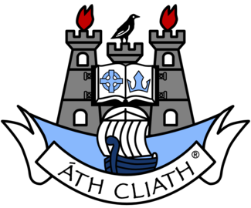
Friday is a Blue Day in St Kevin’s!
To support our Dublin ladies and men in the all-Ireland finals this weekend we will be turning blue for the day!!!! To show our support for both teams all our children are invited to wear something blue to school on Friday 13th September 2019. We ask for each child to bring in €2 on the day & we will use this money to reinvest in our sports equipment.
Come on the boys & girls in blue!!!!
Don’t’ forget: All school correspondence is by email therefore, please ensure we have your email address on our system. A hard copy of newletters, correspondences will be placed on the office window for all to see. To support our Green schools ethos and to keep costs down no hard copies will be printed.

