To celebrate World Book Day we have a few things planned in our school.
Monday: Our children will enjoy story time or DEAR (Drop Everything And Read) time in their classroom.
Tuesday: Bring your favourite book to school & share with your class.
Wednesday: ‘Design a book cover’ competition. This will be held in school & hung in the school hall, check out our website for our lucky winners!
Thursday: Bring a book/ buy a book. We ask for your support to bring a book to school for our book fair. All children will be introduced to the book fair during the day & will be given the opportunity to buy a book! We ask that children will bring €1 only. All money goes to promoting reading within our school.
Friday: Come to school dressed as a character from your favourite book.

On Thursday your community dental nurse visited our 1st & 2nd classes educating our children in relation to the importance of caring for their teeth.

Food Dudes
Here in St Kevin’s we continue to promote healthy eating and we are always delighted to see your continued support through the provision of healthy snacks and lunches.
In keeping with our healthy eating policy our children were introduced to the ‘Food Dudes’ programme on Friday. All our children were encouraged to taste some red & yellow peppers. We were delighted to see such a positive response and interest from our children.
This week we will continue to promote the eating or simply tasting of different fruits & vegetables.
Save the date! March 16th we will hold our 1st St Patricks Day Parade! This will be on the school yard from 1.30-2p.m for all our children. Family & friends are welcome. Let’s hope the sun shines. Further details will follow.

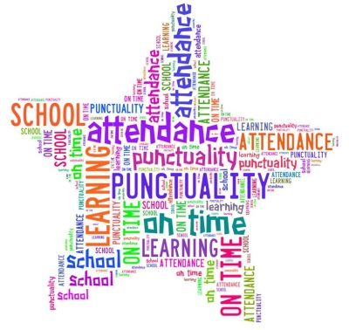Importance of School Attendance
Do you know how much short absences add up to in a year?
If your child is 10 minutes late each day it adds up to missing 4 days each year!
If your child is absent one day every two weeks, it adds up to missing 13 days in a year!
EVERY MINUTE AND EVERY DAY COUNTS
Due to the cumulative nature of the curriculum content, every day and every lesson matters in the development of a child’s intellectual, emotional and social development.
Please note: If for any reason you need to collect your child early, please e-mail the school or write a note to your class teacher explaining the reasons for early collection. This will ensure your child is ready for collection and it has minimum impact on the class teaching of their fellow students.
All early collections will be noted on our roll book facility, when deemed necessary by the school this formation may be shared with our Educational Welfare Officer.
Please note it is against our child policy for any adult to have access to our classrooms without the appropriate Garda vetting which is made through our BOM. Therefore, we wish to thank all parents/guardians who continue to respect our requests to wait outside the front door when collecting their child(ren).
To reduce the cost of paper on our school & on the environment, all our school /notes will continue to be e-mailed. If you have not received a copy, please e-mail the school with your details. If you do not have an email please keep an eye on our school website & look out for a copy of all notes which will be placed on the school do

