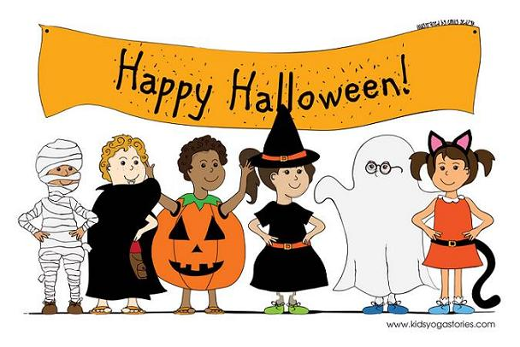

Our Halloween hampers are back!
Tickets €2 or 3 for €5
One hamper per class
The raffle will take place during our whole school assembly on Friday!
