St Kevin’s Junior School

**February 16, 2017**

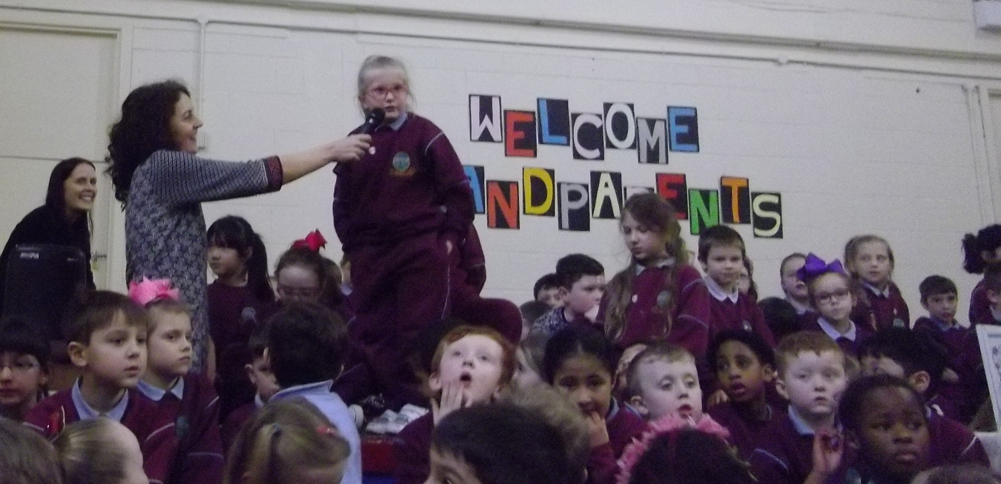

Grandparents Day

A big thank you to all the parents and grandparents who came to visit our school last Friday. It was a lovely morning and an exciting morning for our children. We hope all the grandparents enjoyed this opportunity to come and see their grandchildren in school. We hope they enjoyed this opportunity and time to look around our school and see their grandchild in their classroom.

We are mindful of the importance of this event therefore, we shall include this date annually in o**u**r school calendar.

Dates to remember:

Mid term break Monday 20-24th February.

Please note today is a normal day in school.

First Communion date: Sunday 28th May.

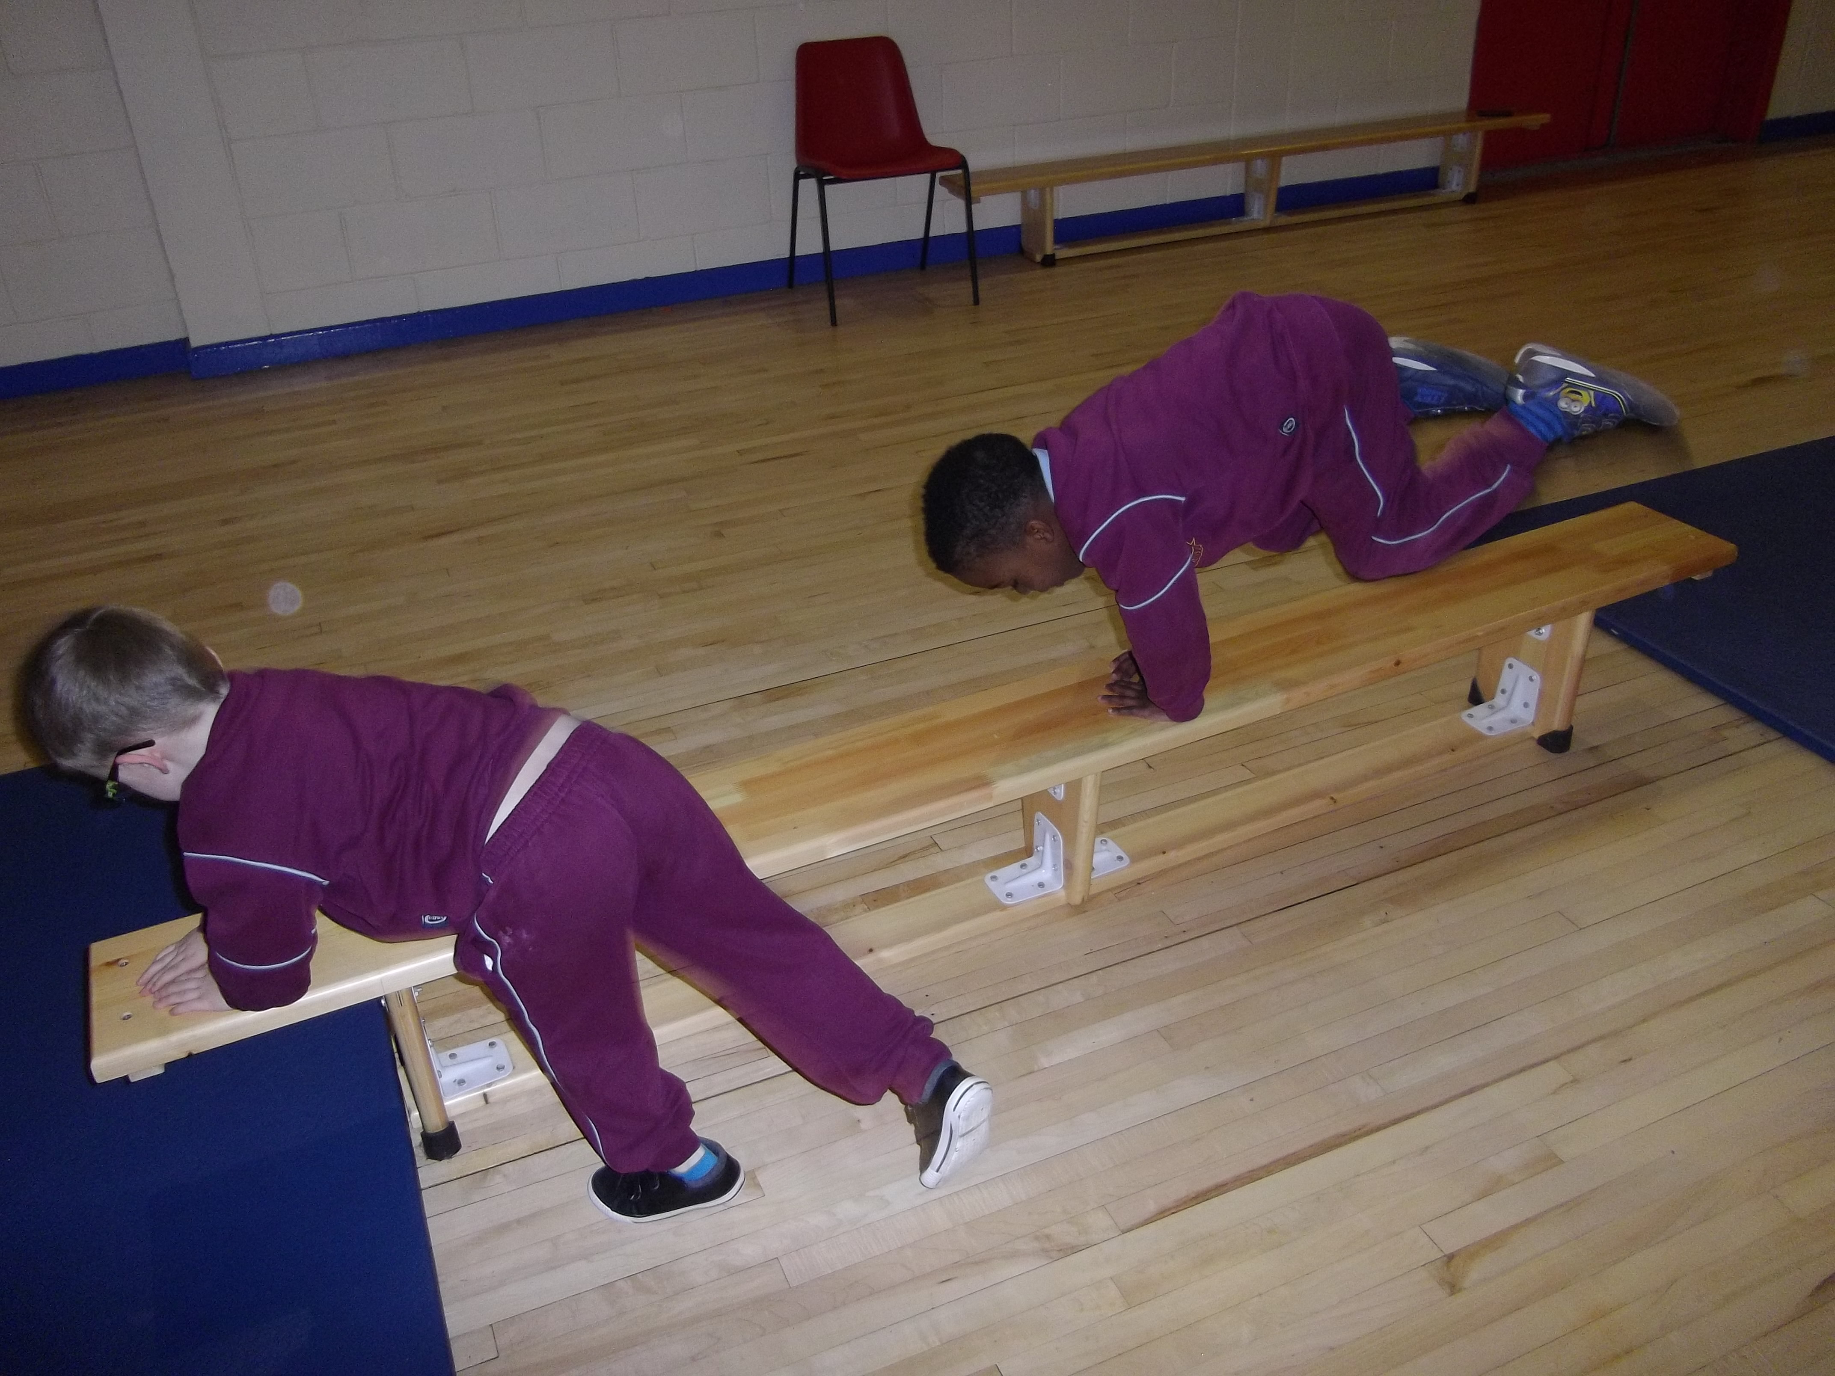

Operation Active School

Since returning to school in January we have been on a mission to improve the health and fitness levels of all our students. Every Wednesday we have ‘Wake up Wednesday’ . On Wednesday morning our entire school head out for a brisk walk or jog around the park. This commences at 9am therefore it is important your child is in the line on time!

Jackie has just completed a 6 week programme of gymnastics with all our children in the school hall. While Debbie completed a 6 week hip hop dance programme. The children loved both activities and participated fully in all activities. This was possible through the money received from our book lists at the beginning of the year. Thank you.

GAA will continue with Junior Infants and first class until the end of term. If your child has an interest in joining GAA please contact Neil O’Driscoll the Trinity Gaels Games Promotion Officer by email for further information in relation to times & dates. [neil.odriscoll.gpo.dubli@gaa.ie](mailto:neil.odriscoll.gpo.dubli@gaa.ie)

A big well done to all our children who participated in Operation Transformations 10@10 initiative. This was a fun activity and all children were rewarded for their participation.

We ask you to continue promoting healthy exercise outside of school by walking, cycling or skating with your child each morning as they make their way to & from school.

**10**

**First Penance**

A big congratulations to all our second class children who received the sacrament of First Penance in Holy Trinity Church. This was a lovely celebration with Fr Gerry and the children of St Francis of Assisi school.

**Pets at School**

We love hearing all about our children’s pets, we especially love to see photos of them. But please, please, please leave them at home!

We wish to remind you that no dogs are allowed on the school premises. This includes the school yard & garden. We were disappointed to hear stories in relation to dogs soiling in our school garden. The school garden is designed as an outside classroom. We use this space with our children frequently throughout the year therefore we ask for your support to keep it clean & free from dog litter or any other forms of litter.

Driving on to school Grounds

Once again we wish to thank the parents who respect our continuous request not to drive on to the school ground. We once again wish to remind all parents that there is no driving permitting on our school grounds. This applies in the afternoons also. It is with disappointment that we continually see parents of children from St Kevin’s Junior School driving and turning their cars in the staff car park in the mornings again at 1:30 & 2:30.

For the safely of all please do not drive beyond the school gates.

Please note it is important to be in the line for ten to nine!!!

All children must wait in their line supervised by their parents &/or guardians. Supervision is not provided by the school therefore you must wait with your child until the teacher or principal meets their class line.

All children must dismount their bikes/flickers/scooters at the school gate and walk to thee line. This is to avoid any unnecessary accident or injury.

**Crazy Tuesday**

We have introduced Crazy Tuesday in our school. This is a wonderful opportunity for children to work with other teachers in a different setting. Every second Tuesday your child will get an opportunity to have a little fun with another teacher. This will help them with the transition of moving to a new class in the new school year & it allows for a little fun in another space with access to different resources, games & activities.